Update Collection Details By Items

Click “Update Collection Details By Items” link from menu to update collected item quantity

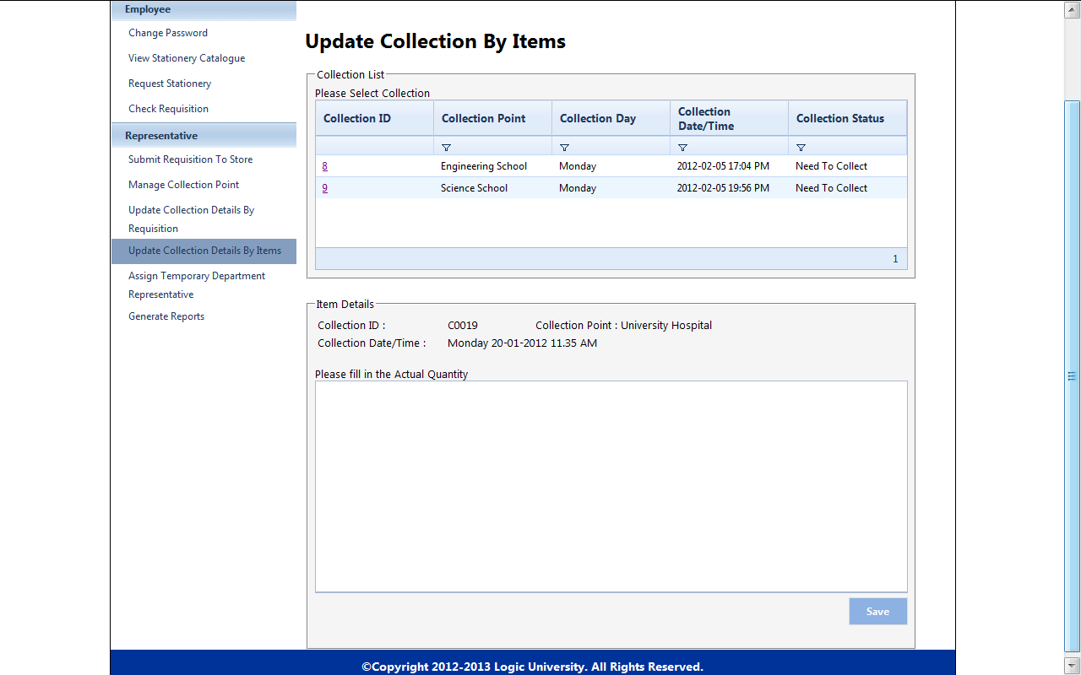

Click collection ID and update this collection item quantity

(s)